IT Solutions Portfolio Website
Project Domain / Category
Ecommerce Application

Abstract / Introduction
This project involves the design and development of a comprehensive portfolio website for a software development company using WordPress. The site will serve as a central platform to showcase the company’s profile, domain-specific software products, solutions, research publications, and software repositories. Built with tools like Elementor, Custom Post Types, and Download Manager, the website will feature user-friendly navigation, a responsive design, and a well-structured content layout. It will include interactive components such as publication downloads, user ratings, and repository sharing. The platform will support both open-source and premium downloadable content, allowing the company to share knowledge while also generating revenue. Integration with GitHub and admin tools like Forms and Member Press will provide robust content management and user access control, delivering a modern, scalable, and feature-rich web presence.

Sample Website:
https://www.bmc.com/

Functional Requirements:
FR1 – Home Page with Sliding Panel (Carousel)
- Responsive sliding carousel with three visually engaging panels.
- Each slide includes a key message, background media, and “Explore More” button linking to About section.
- Introductory section with quick navigation and company overview.
FR2 – About Page
- Displays company mission, vision, background, and goals.
- Team section with photos and roles.
- Optional timeline showing company milestones.
- Clients messages/reviews with photos.
FR3 – Products Page
- Products grouped by domains: Automation, Digital Services, Healthcare, Education, Finance, E-commerce, Transportation & Logistics, Entertainment & Media, Human Resources, Prediction and Optimization etc.
- Each domain uses a horizontal slider showing: Product image, title, caption, and “Learn More” button.
- Domain filter for easy browsing.
Sample Products Drop down Menu Item:
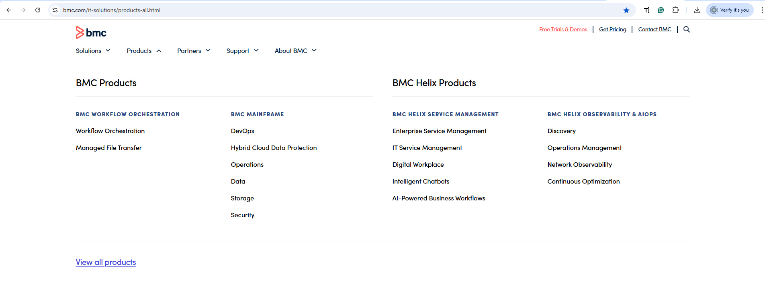

FR4 – Solutions Page
- Solutions displayed with title, icon/image, and summary.
- Organized by problem areas with slider-style display.
- Option to view detailed use case/demo (images or video).
Sample Solutions Drop down Menu Item:
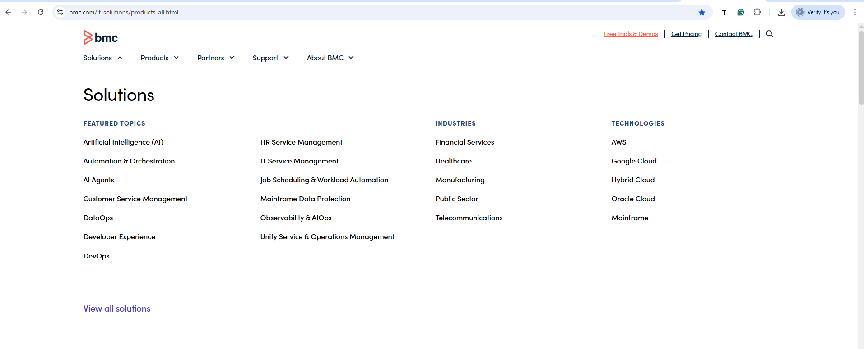
FR5 – Research & Publications Page
- Each publication includes Title, authors, domain, abstract, thumbnail or video teaser, and a download button.
- Registered users can comment and rate publications.
- Admin can moderate or delete comments.
Sample design:
https://www.bmc.com/education/courses/find-courses.html#&sortCriteria=recommended&category=education

FR6 – Filter Publications by Domain
- Filter by research domain (AI, ML, Cloud, etc.).
- Search by title, keywords, or author name.
FR7 – Repository Page
- Displays downloadable software assets as:
• Free (open source): GitHub link for direct download
• Premium: Requires contacting admin to access
- Each item includes Title, description, tags (e.g., Free, Paid), download link or contact button, license, and version info.
FR8 – Global Search Functionality
- A global search bar in the header.
- Searches Products, Solutions, Publications, and Repository.
- Filters and links to relevant pages.
FR9 – Contact Page
- Contact form: Name, Email, Subject, Message.
- Submissions stored in the database and optionally emailed to admin.
- Includes Google Map, phone, email, and social links.
Sample Page:
https://www.bmc.com/forms/contact-bmc.html?productInterest=all%20pl%20products
FR10 – User Authentication & Access Management
- ASP.NET Identity for login/registration.
- Roles: Admin, Registered User, Guest.
- Secure premium content download with access control.
FR11 – Admin Content Management Panel
- Admin can upload, edit, delete the products, solutions, publications, comments and reviews.
- Admin can block users.
FR12 – Header and Footer Consistency
- All pages have consistent layout.
- Header: Logo, navigation, search.
- Footer: Contact info, social icons (Facebook, LinkedIn, YouTube), and copyright.
FR13 – GitHub Folder Download Integration
- Free Items:
• “Download from GitHub” button opens GitHub link
- Premium Items:
• “Contact Admin” button opens contact form or email
- Items include GitHub Link and Is Premium flag in database.
- Secure and intuitive download access based on user role.
Admin Side Functional Requirements:
- AR1 to AR12 includes full admin control over content, users, comments, and repository.
- Features include search, filters, audit trail, visibility toggling, and activity logs.
Important Requirement:
All the demos or videos shown in website will be first uploaded on YouTube channel (same name of company name), then use its video link to preview it inside website.

Tools:
WordPress:
- Elementor
- Astra (or OceanWP)
- Custom Post Type UI
- Advanced Custom Fields (ACF)
- Download Manager (or Easy Digital Downloads)
- WPForms
- MemberPress (or Ultimate Member)
- WP Review (or Site Reviews)
- Search & Filter Pro

Supervisor:
Name: Neelam Alam
Email ID: neelam.alam@vu.edu.pk
Skype ID: neelam-cs

